Making History Accessible
Toolkit for Multisensory Interpretation

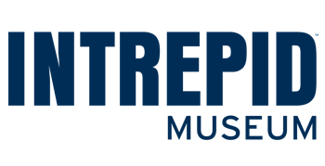
Intrepid Museum + NYU Ability Project

Contents
Making History Accessible 1
Contents 2
Introduction 5
Toolkit 7
Incorporate Multisensory Engagement 7
Leverage the Five Senses 7
Provide Multiple Ways of Interacting with Content 7
Use Co-Design Methods 8
Engage Partners in a Core Working Group 8
Disability Advocates 8
Universities 9
Local Community Organizations 9
Explore Ideas 9
Design Prototypes 10
Test & Iterate 11
Fabricate Interactive 11
Build Institutional Capacity 12
Survey to Identify Opportunities 12
Work Within the Constraints of Your Organization 12
Train Staff on Accessibility 13
Disability Language 13
Visual and Verbal Description 13
Using Templates 14
Resources 15
Evaluation Templates 15
Accessibility Presentation 15
Smithsonian Guidelines for Accessible Exhibition Design 15
Web Content Accessibility Guidelines 15
Alternative Text 16
Plain Language 16
Visual Design 16
Acknowledgements 17
Core Working Group 17
Partner 17
Advisors 17
Historic Sites and House Museums 17
Disability Advocates 17
Facilitator & External Evaluator 17
Individuals 18
Organizations 18
Appendix 19
Project Background 19
Mid Phase of the Project 20
Project Checklist 21
Vision 21
Staff and Support 21
Approach and Execution 22
Sample Letter/Email 23
Local Community Organizations + List 24
Evaluation Templates 25
Example Surveys 25
Observation Protocol 28
User Testing Observations 29
Project Case Studies 30
Case Study 1: Tactile Experience 30
Case Study 2: Tactile Experience 31
Case Study 3: Tactile Experience 32
Case Study 4: Olfactory Experience 33
Case Study 5: Digital Mobile Guide 34
Case Study 6: Content 35
Case Study 7: Multiple Perspectives 36

Introduction
It is estimated that 25% of adults in the United States have a disability, whether it’s sensory, physical, learning or cognitive (CDC 2020). Yet, less than 7% of adults with disabilities are visiting museums (National Endowment for the Arts 2015). Museums that interpret historic sites must balance their obligations to protect and preserve the integrity of historic structures and landscapes with the growing need to provide an accessible visitor experience. Historic sites, historical societies or historic preservation organizations are the largest category of museums in the United States at 45% (IMLS 2018).

A significant challenge for historic sites and house museums is how they interpret their stories. A majority of historic sites and house museums rely primarily on visual displays. For preservation and safety reasons, these displays are often behind a rope, under glass or next to a “do not touch” sign (Handa, Dairoku, and Toriyama 2010). We learn and engage through multiple senses: touching, hearing, smelling, tasting and seeing. In order for historic sites and house museums to be accessible, their content must be interpreted in a multisensory way that invites everyone to participate. Developing multisensory interpretation can be challenging for those with limited staff, volunteers and budgets.

To make interpretive content at historic sites more accessible, we present our toolkit for multisensory interpretation. The goals of this toolkit are:
- Understand accessible interpretation guidelines.
- Learn accessible design processes, no matter the size, space or resources of the historic sites and house museums.
- Leverage multisensory experiences to increase access in these environments.
The toolkit was developed with a core working group of participants from historic sites and house museums, as well as disability advocates and university advisors with prototyping capabilities. It offers a set of creative, low-cost solutions around increasing access, enjoyment, engagement, appreciation, and understanding of historic sites and house museums. It has the potential for broader application in other types of educational and experiential facilities, such as botanical gardens, museums, zoos, aquariums and planetariums.

Based on needs and preferences of the disability advocates, and input from the historic site and house museum collaborators, the following themes were selected as key approaches to increase access to interpretation. These concepts inspired the recommendations in this toolkit.

Physical Experiences:
- Tactile Experiences - Touch experiences can help visitors better engage with content.
- Bring Stories out from Behind Glass - Offer reproductions of key artifacts in an accessible, interactive environment to enhance engagement with interpretation.
- Multiple Senses - Enhance interpretation through multisensory experiences, including tactile, audio and olfactory resources.
- Multiple Perspectives - Interpret environments, objects and stories from several points of view.
- Accessible Content Design - Use plain language to engage with more visitors.

Digital Experiences:
- Accessible Mobile Device - Support autonomous navigation of spaces and content by creating accessible digital content that can be accessed on personal mobile devices.

Toolkit

Incorporate Multisensory Engagement

Leverage the Five Senses
Visitors interact with historic sites and house museums using their senses. Not everyone interacts in the same way. Some visitors learn best through touch, some through hearing and some through sight.
- Allow interaction with historic spaces and associated exhibits through multisensory engagement. This makes content more accessible and meaningful to visitors with and without disabilities.
- Make sensory exploration optional because while some visitors appreciate it others may become overwhelmed.

Provide Multiple Ways of Interacting with Content
When we presented interactive information visually, we also provided equivalent audio and tactile representation.
- This can be achieved in many ways, including a kiosk in front of a barrier with a tactile graphic or model and a button that plays and pauses an audio description of the furnishings, space layout, key artifacts, or other significant features of the space behind the barrier.
- Taste and smell experiences can enhance an exhibit design, as long as they are optional for those with sensory sensitivities.
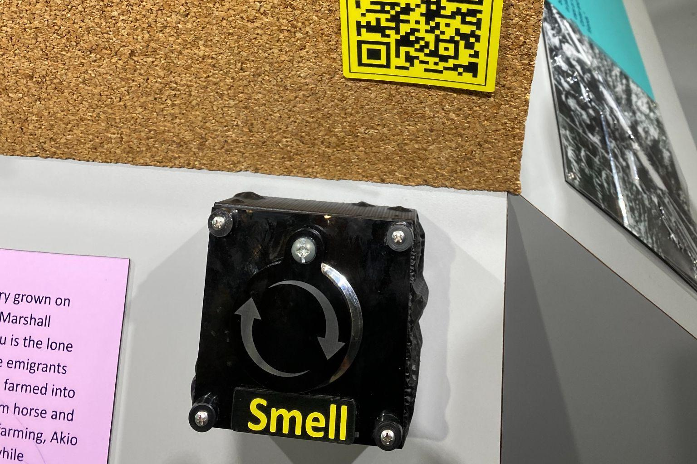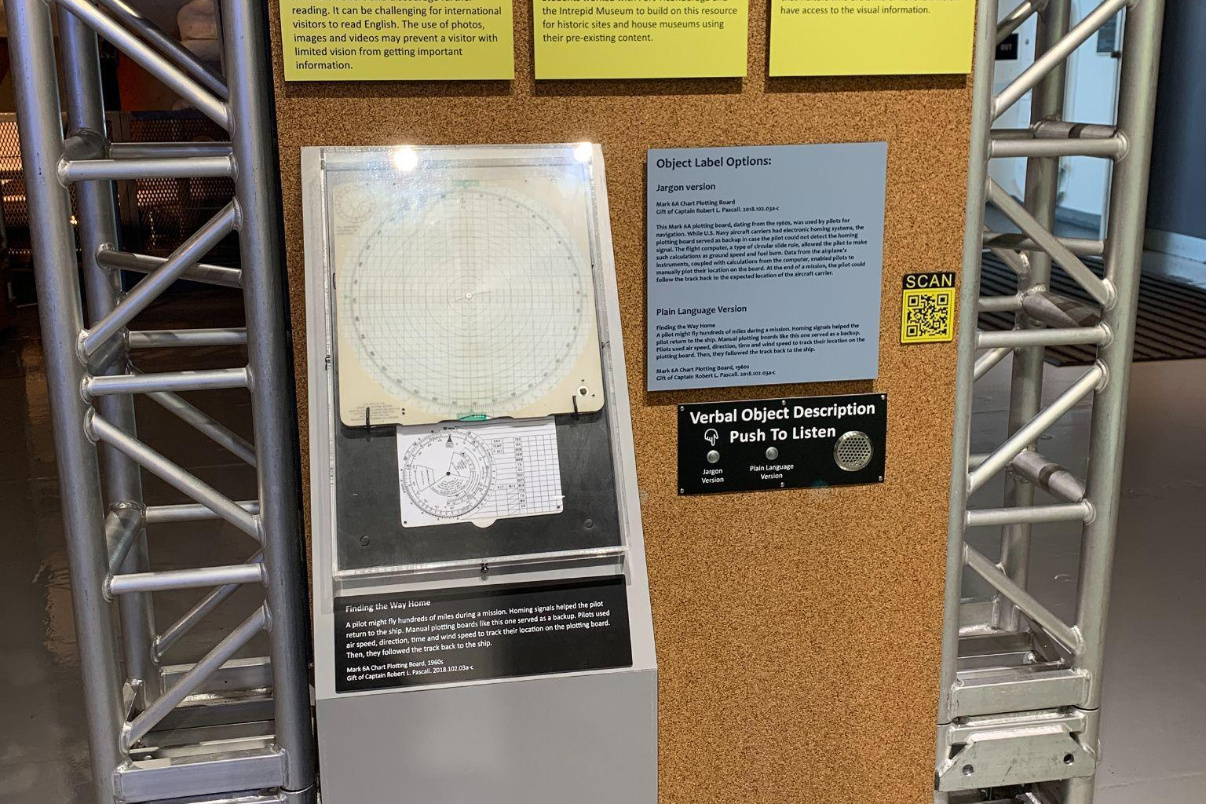
Caption: Left, this smell box has a lid that slides open to release the scent only when wanted, and that closes when released without risk of injury to fingers. Right, this display of a navigational chart includes a button that visitors can push to play audio of the label text and detailed visual description of the artifact.

Use Co-Design Methods
Co-design involves the inclusion of diverse individuals’ perspectives in the entire design process (Steen 2013), or the goal of designing with rather than designing for.

Engage Partners in a Core Working Group
For this toolkit, we co-designed prototypes with a core working group of experts. In this toolkit, we define the core working group as the group of disability advocates, universities, and local community organizations working with the historic site.

Disability Advocates
“By consulting with eight disability advocates, we were able to identify barriers to inclusion and accessibility early on in the design process.”
By consulting with eight disability advocates, we were able to identify barriers to inclusion and accessibility early on in the design process. We recruited our cohort of individuals by working with local and national organizations which have strong reputations. It was important to ensure that the final cohort represented a spectrum of disability identities. The cohort was involved throughout the entire process, generating project ideas, and periodically reviewing prototypes to provide feedback and recommendations to the team. This was crucial in preventing access barriers that would have been more difficult to fix later on.

It is a best practice to compensate people for their time and expertise.
- Design your budget to compensate the advocates at the standard hourly rate for a professional consultant.
- Grant complimentary access to the core working group.
- During on-site meetings, meals and snacks should be provided.
- Recruit disability advocates with an even distribution of sensory, physical, cognitive, and learning disabilities to ensure that a broad spectrum of experiences are represented.

Universities
Partnering with universities and community colleges creates opportunities for offering students real-world experience and provides historic sites and house museums much-needed support. It often increases the opportunity to conduct research and receive external funding. For this project, our university partner designed a graduate-level course during which students developed creative solutions to challenges identified by the disability advocates and historic sites.
- We recommend partnering with university faculty, staff and students as they likely have access to prototyping expertise, resources or tools. Reach out to your local community college or university. Key departments may include Occupational Therapy, Museum Studies, Disability Studies and Design Engineering. These relationships need to start months before your project begins, in order to implement them during an academic semester.

Local Community Organizations
In addition to disability advocates, maker spaces and universities, we partnered with local community organizations for project support near the historic sites and house museums. This included libraries, disability organizations, museums and fabrication specialists.
- We recommend reaching out to local community organizations who can provide expertise beyond your core working group. (See Appendix.)

Explore Ideas
Working with core working group members who have a range of expertise and lived experience provides fresh perspectives and generates innovative ideas. Once project partners have been selected, we recommend an initial session to generate and choose ideas to design. In advance of the meeting, reach out to working group members to identify any accommodations or access requirements, such as a real-time captioner, ASL interpreter or large text of printed materials. Some activities we recommend during the session include:
- Brainstorming: Pose a question the group would like answers to, and generate as many ideas as possible within a fixed time frame. Assign a staff member to take notes.
- Conversation Starters: Share a few ideas with the core working group to get initial reactions from everyone.
- Storyboarding: Work in teams to define narratives for how a visitor would engage with a prototype idea.
- Sharing: After each session, email to the group a recap of the notes taken. This provides an opportunity to identify any miscommunications and provides transparency in the process.

Design Prototypes
“Prototyping allows for input from partners early in the process when it is easier to design with access in mind…”
Prototyping allows for input from partners early in the process when it is easier to design with access in mind rather than to fix issues later. This early collaboration can reduce the number of iterations needed during prototyping. Each prototype interaction should build on partner input. Prototypes can range from simple and low-cost to complex and high-cost, including tactile graphics, text panels, physical and digital elements, and audio components. For example, low-cost audio description might use video conferencing software, such as Zoom, to create a recording with historic sites and house museums staff, while high-cost might use a professional voice actor and production studio.
- In addition to the teams at historic sites and house museums, we recommend leveraging project partners to create prototypes.
- We suggest field-testing prototypes at historic sites and house museums to gather accessibility feedback from project partners and visitors.
- Based on your site, some approaches may need to be incorporated as part of a guided tour experience offered by a docent, volunteer or educator. All of these positions can make the interpretive experiences even more meaningful.
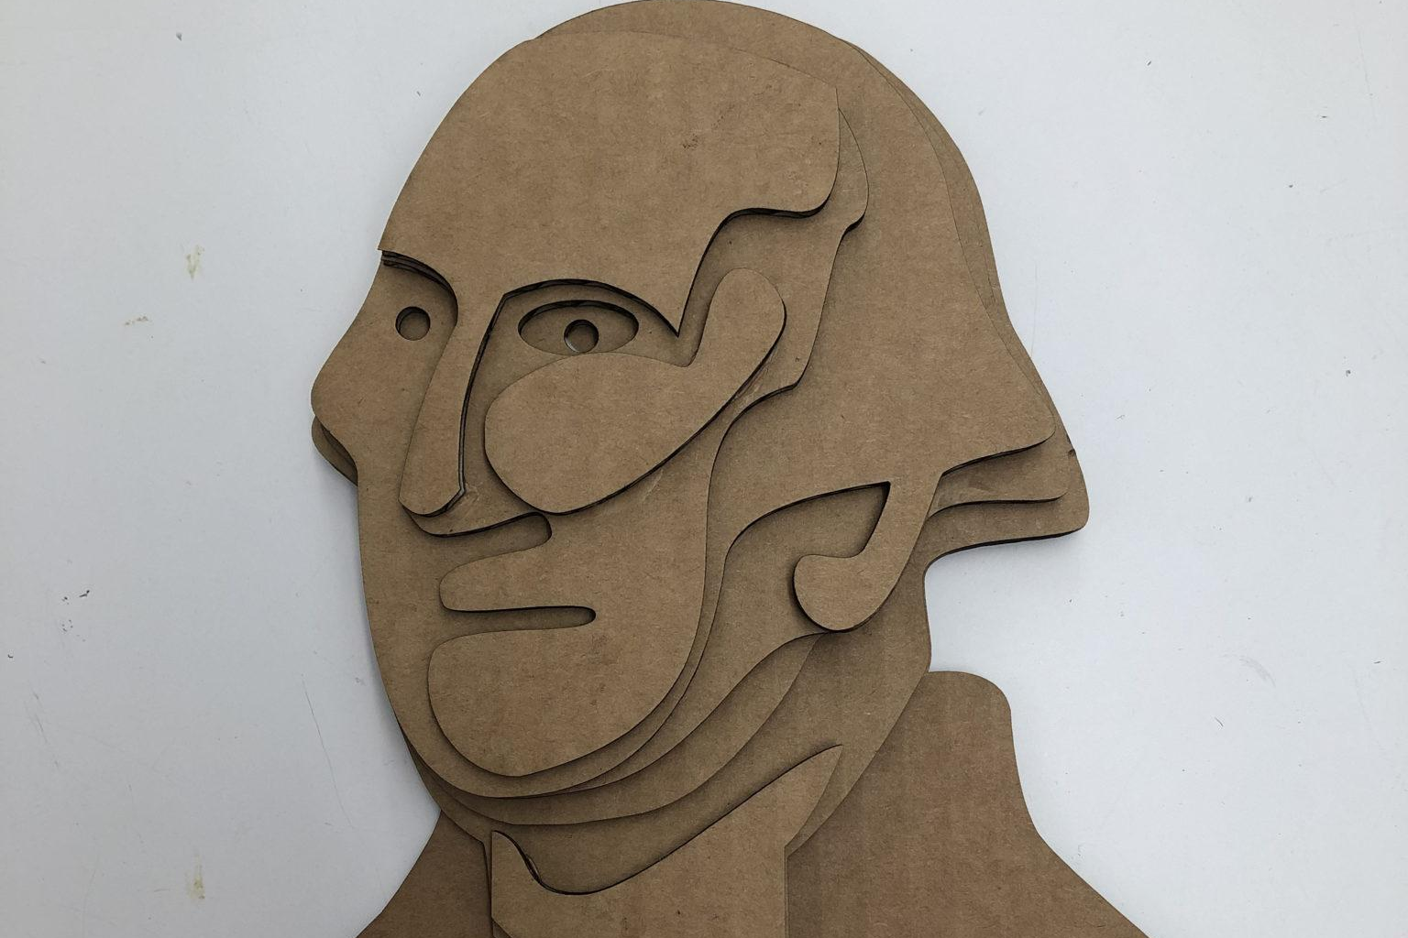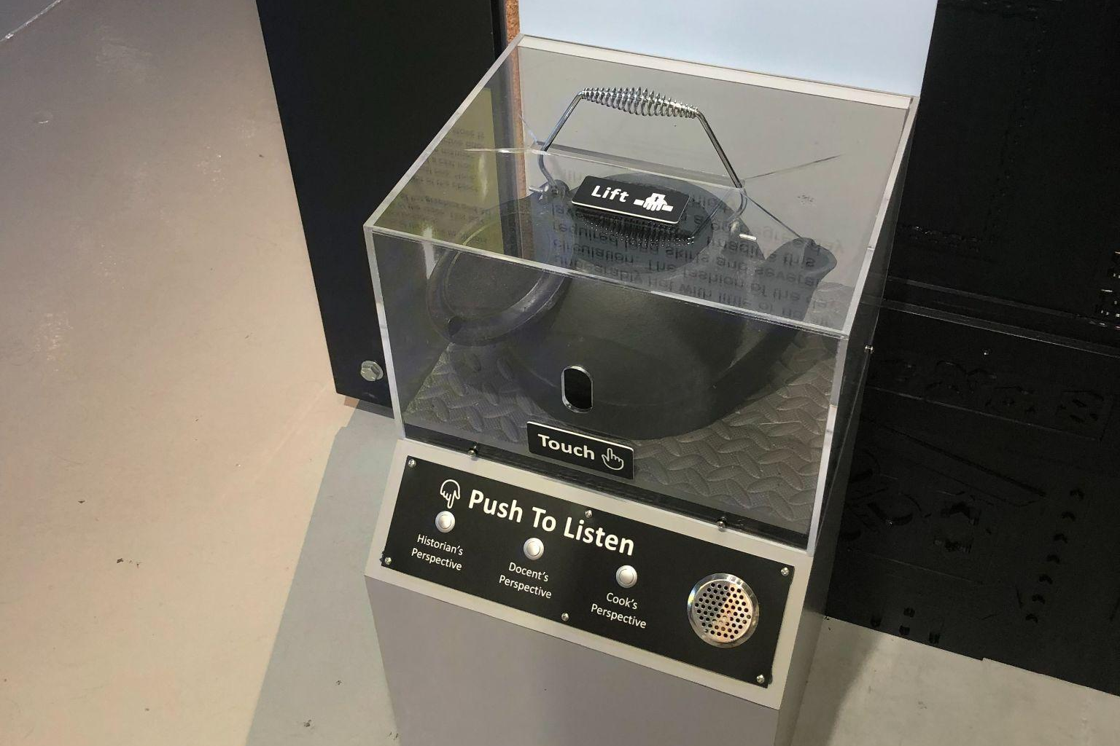
Caption: Left, a simple and low-cost cardboard tactile graphic prototype of a portrait of George Washington designed to emphasize George Washington’s soft, aging jowls, rather than other details. This was paired with an accompanying tactile graphic of an earlier portrait for comparison. Right, a more complex and higher cost tactile and audio interactive of a cast iron kettle. Visitors could safely lift the kettle and feel it through a slot in the protective plexiglass case, and press buttons to hear interpretations of the artifact from three different perspectives. This was modified for the final version based on user feedback.

Test & Iterate
Once our team created prototypes, we tested them with disability advocates and local members of the disability community. We tested informally, working with our professional contacts to provide feedback. We also tested more formally by setting up a temporary exhibition from which we gathered feedback from visitors with and without disabilities. With our learnings from testing, we implemented changes into the next iterations of our prototypes.
- Reach out to visitors with disabilities early in the design process to prevent creating access barriers. (See Appendix.)
- Have people with disabilities on your design team because lived experience is extremely valuable.
- Allow for flexibility and adaptability in your testing process to make it more accessible. Things such as making questions available in various formats, allowing ample time for responses, and providing a schedule in advance, set expectations and allow for multiple ways of engagement.

Fabricate Interactives
“Partner with a nearby university, local vendor or maker space when developing multisensory interactives.”
We leveraged our network to try out different maker spaces, local vendors and universities before choosing the ones that worked for us. With access to digital and analog fabrication tools, we fabricated final interactives for visitors.
- Partner with a nearby university, local vendor or maker space when developing multisensory interactives. Universities often have maker space resources, as well as students and faculty with digital fabrication skills.

Build Institutional Capacity
Beyond partnering with local organizations, building institutional capacity enables project upkeep and longevity. This includes staff training, budgeting, policies and support to ensure that the staff are supporting this effort.

Survey to Identify Opportunities
We surveyed employees and staff at our historic sites and house museums to identify areas of accessibility improvement, and invite stakeholder input on the project.
- Reach out to employees who interface with the public to learn where they have identified access barriers with visitors to the historic sites and house museums.
- Survey staff to learn their level of accessibility knowledge, identify skill gaps, and determine the training they would need to confidently support visitors with disabilities.

Work Within the Constraints of Your Organization
“Our team worked within the constraints of the resources and tooling available, to produce the highest quality multisensory interactives possible.”
Our team worked within the constraints of the resources and tooling available, to produce the highest quality multisensory interactives possible. We learned that there are limits for every organization, ours included. We reduced costs by partnering with university students, and selecting less expensive prototype solutions.
- Some multisensory interpretation is better than none at all, so we recommend doing what you can with what you have, and seeking support where you need it most.
- It is important to be transparent with your partners and advisers about constraints with budget, time and staffing from the beginning. Setting clear expectations about what is possible will help manage brain-storming and planning conversations. Collaborators may also be able to suggest creative solutions.

Train Staff on Accessibility
It is an asset that all staff know the basics about accessibility so they can better serve visitors with disabilities. The basics include disability language, best practices, and making use of accessible templates.

Disability Language
“Language is constantly changing, including language used to talk about disability.”
Language is constantly changing, including language used to talk about disability. Outdated or offensive language is disrespectful and can damage relationships with disability advocates. Our core working group was made up of members with diverse disability identities and everyone identified in their own way (either person-first or identity-first). With identity-first language, the disability is first in the description, sometimes with a capital letter (e.g., Blind person, Disabled person). With person-first language, the person is first in the description (e.g., a person who is blind, a person with a disability).
- Language preferences can depend on the group, and it is a best practice to ask the individual which language they prefer. Without other guidance, a good starting place is to use either person-first or identity-first language when talking about disability.
- Educate staff on rejecting outdated and offensive disability language (Cavender 2022, Ladau 2021). Language around disability continues to evolve, so it is important to be proactive about checking preferences and best practices.
- Respect the complex ways in which people identify. If you don’t know how someone identifies, it helps to ask.

Visual and Verbal Description
“Accessibility best practices focus on the different ways in which visitors access information and learn, such as through sight, hearing or touch.”
Accessibility best practices focus on the different ways in which visitors access information and learn, such as through sight, hearing or touch. Our goal is to give visitors as much multisensory access as they would like. This means interpreting historic sites and house museums through verbal or textual description, video and imagery, immersive experiences, and touch objects.
- Train staff on giving detailed verbal descriptions of artifacts (Art Beyond Sight n.d.).
- Present all interpretive content through an accessible and WCAG-compliant responsive website using Wordpress’ accessibility-ready templates, allowing visitors to access content with their customized assistive technologies (Wordpress n.d.).
- Incorporate visual description and context-providing images and videos directly into content, and give users the choice to access more in-depth content (Race et al. 2021).
- On site, provide verbal description of historic spaces, and open captioning on all videos. On the Wordpress website, provide textual description of artifacts, and closed captioning on all audio and video. Make sure to proofread all captions.
- Follow accessible exhibition design guidelines outlined by the Smithsonian (Smithsonian n.d.).

Using Templates
The core working group used accessibility-ready templates to build websites for their historic sites and house museums. These templates are designed to be accessible from a visual, and often functional standpoint. This plug-and-play approach allowed the team to achieve easy accessibility wins, saving more complex issues for a specialist. It also meant that non-experts could build a website with accessibility in mind, before engaging with usability testing and subject matter experts.
- Use Wordpress’ accessibility-ready templates to get started.
- Conduct usability testing with people with disabilities to find more complex issues in your website.

Resources

Evaluation Templates
When evaluating your website and on-site interpretation, our team compiled a template to guide and record user testing along with a simple survey for user feedback. Sites should feel empowered to adapt as needed for their work.
- Survey
- Observation Protocol

Accessibility Presentation
Accessibility presentation documentation supports designing inclusive websites and on-site interpretation for historic sites and house museums. Though these resources help set a baseline for accessibility, it is rarely possible to design experiences that meet everyone’s needs. We recommend thinking of these resources as a starting point, and then prioritizing usability testing with people with disabilities.

Smithsonian Guidelines for Accessible Exhibition Design
Given that historic sites and house museums are public spaces, interpretation must be designed to be accessible to visitors with disabilities in addition to the requirements of the Americans with Disabilities Act. This includes interpretive content, audiovisuals and built environment.
- Smithsonian Guidelines for Accessible Exhibition Design

Web Content Accessibility Guidelines
The Web Content Accessibility Guidelines, or WCAG (often pronounced “wuh-cag”), is the worldwide industry standard for digital accessibility. Its main goal is to offer guidelines which measure website accessibility. These guidelines ensure that websites are perceivable, operable, understandable and robust for people with disabilities. Checklists translate WCAG into easy-to-understand lists for non-experts. The A11y Project checklist is written in direct, plain language, and helps teams achieve easy accessibility.
- Web Content Accessibility Guidelines (WCAG 2.1)
- A11y Project Checklist

Alternative Text
Images, charts and graphics on websites must incorporate alternative text or image descriptions, in order to be accessible to screen reader users. Screen readers are a type of assistive technology that convert digital text to either dynamic braille or synthetic speech (American Foundation for the Blind n.d.) A good image description is concise. The goal is to express the image’s purpose. WebAIM provides a short article on how to write alt text.
- Web AIM Alternative Text

Plain Language
Plain language is a writing style that is simpler to understand by simplifying the language, not the concepts. Instead of weakening content, it strengthens it by making interpretive content easy to read (Making History Accessible 2021). Plain language tools support the effort to make content readable and understandable to visitors with and without disabilities and those who speak English as a second language. These tools, such as Hemingway, help practitioners write at an accessible reading level. They help avoid using jargon, challenging words and hard-to-read sentence structure. Writing in plain language may also make it easier to translate information to other languages (Google Translate n.d.).
- Hemingway Editor
- Microsoft Office Readability Stats
- Readable

Visual Design
WCAG requires website components to be accessible from a visual design perspective. This includes addressing color contrast, or difference in between the foreground and background colors. They must be differentiated so users can perceive information. Additionally, the size of tap targets, the buttons, text boxes, or menu a user may interact with, must be large enough so that users can operate the controls. “Accessibility ready” themes on Wordpress have those requirements built in and save a lot of time. If you’re not using these kinds of themes, WebAIM has a color contrast checker that identifies inaccessible color combinations and makes suggestions to fix them.
- Wordpress Accessibility Ready Themes
- WAVE Color Contrast Checker
- Coblis Color Blindness Simulator

Acknowledgements
In this toolkit, we have demonstrated our commitment to collaboration with people with diverse lived experiences and knowledge of both small and large historic sites and house museums. We thank the following individuals and organizations for sharing their knowledge and insights:

Core Working Group

Partner
New York University Ability Project

Advisors
Access Smithsonian
National Trust for Historic Preservation

Historic Sites and House Museums
Bainbridge Island Historical Museum
Brandywine River Museum of Art
Eastern State Penitentiary
Fort Ticonderoga
Fosterfields Living Historical Farm
Intrepid Museum
Louisiana State Museum
Macculloch Hall Historical Museum

Disability Advocates
Ruth Bernstein
Cheryl Fogle-Hatch
Ellen Giusti
Amy Gravino
Emily Ladau
Nefertiti Matos
Shira Mechanic
Michael William Tranquilli

Facilitator & External Evaluator
Janet Rassweiler

Individuals

Fabiha Ahmed
Elizabeth Betts
Annmarie Bobak
Bo Byun
Themis Cadiz Garcia
Melissa Canavan
Lynda Carreno
Elaine Charnov
Mary Cronin
Saarah D’Souza
Omar A. Eton-Martinez
Abigail Faelnar
Rosanna Flouty
Bailey Gamberg
Caitlin Gebhard
Alexsandra Gizzi
Deborah Gorelik
Ashley Grady
Antônio Guimarães
Amy Hurst
Amber James
Nelson James
Daniel Johnston
Matt Keagle
Lynda Kennedy
Dina Khalil
Myra Khan
Daisy Lei
Maren Levad
Sheri Levinsky-Raskin
Lilly Lin
Sarah Liriano
Sara Lowenburg
Chris Malanson
Susan Marenoff-Zausner
Charlotte Martin
Merilee Mostov
Matt Murphy
Jennifer Novicki
Keita Ohshiro
Jorge Otero-Pailos
Anita Perr
Miranda Peters
Patricia Pongracz
Lauren Race
Shehara Ranasinghe
Kyle Shepherd
Barbara Johnson Stemler
Mark Stoner
Irene Tsitko
Carrie Villar
Ling-Hsuan Wang
Laura Westmoreland
Jessica Williams
Ashley Wilson
Cameron Womack
Cathy Xu
Dazhen Yang
Beth Ziebarth
Rena B. Zurofsky

And over 40 students from New York University’s class on Access and Assistive Technology in Historic Sites and Museums taught by Amy Hurst and Anita Perr.

Organizations
Andrew Heiskell Braille and Talking Book Library
NYC Mayor’s Office for People with Disabilities
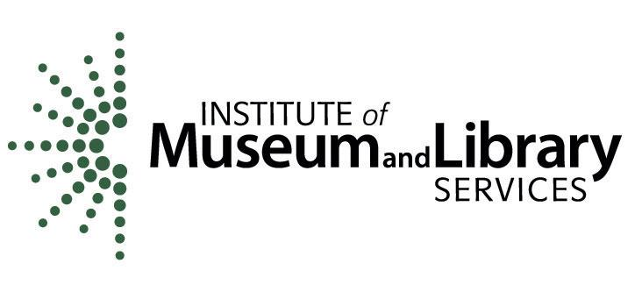
This project was made possible in part by the Institute of Museum and Library Services, IMLS grant number CAGML-247144-OMLS-20. The views, findings, conclusions or recommendations expressed in this publication do not necessarily represent those of the Institute of Museum and Library Services. The project is also supported by the Harry S. Black and Allon Fuller Fund, Bank of America, N.A., Trustee.

Appendix

Project Background
This project set out to tackle the inherent accessibility challenges faced by museums that interpret historic sites and house museums. The goal was to bring together historic sites and house museums, disability advocates, New York University’s Ability Project, National Trust for Historic Preservation and Access Smithsonian, to discuss challenges and ideas. We then developed prototypes and evaluated low-cost physical (tactile, olfactory) and digital experiences at the partner institutions. Based on these findings we have produced this free, digital publication strategy for increasing visitor engagement through interpretation that is accessible for visitors with disabilities and achievable by historic sites and house museums of all sizes.
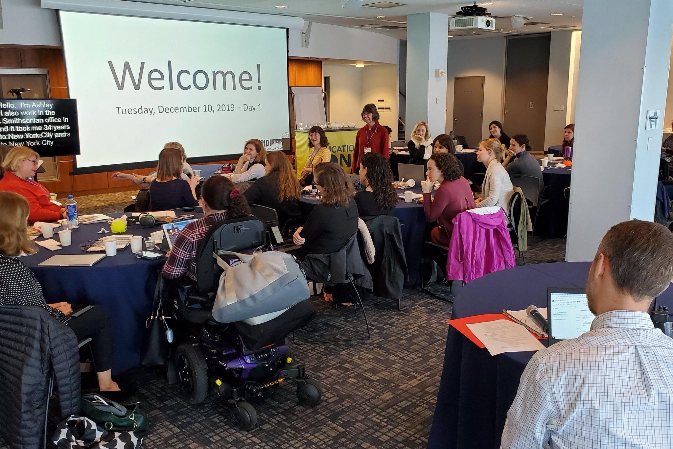
Caption: A meeting with our core working group of experts, which included disability advocates, historic sites and house museums, New York University Ability Project and advisors from Access Smithsonian and National Trust for Historic Preservation.

Mid Phase of the Project
During the course of the project, to address challenges at specific sites, the Intrepid Museum, New York City, staged a small exhibit to share the stories of the national collaboration and early prototypes developed by NYU Ability Project students and the Intrepid Museum exhibits team. The Museum invited local disabled user-experts to explore the exhibition. The team recorded observations and interviewed participants. Subsequently the project ideas were further developed and tested at the site-specific locations.
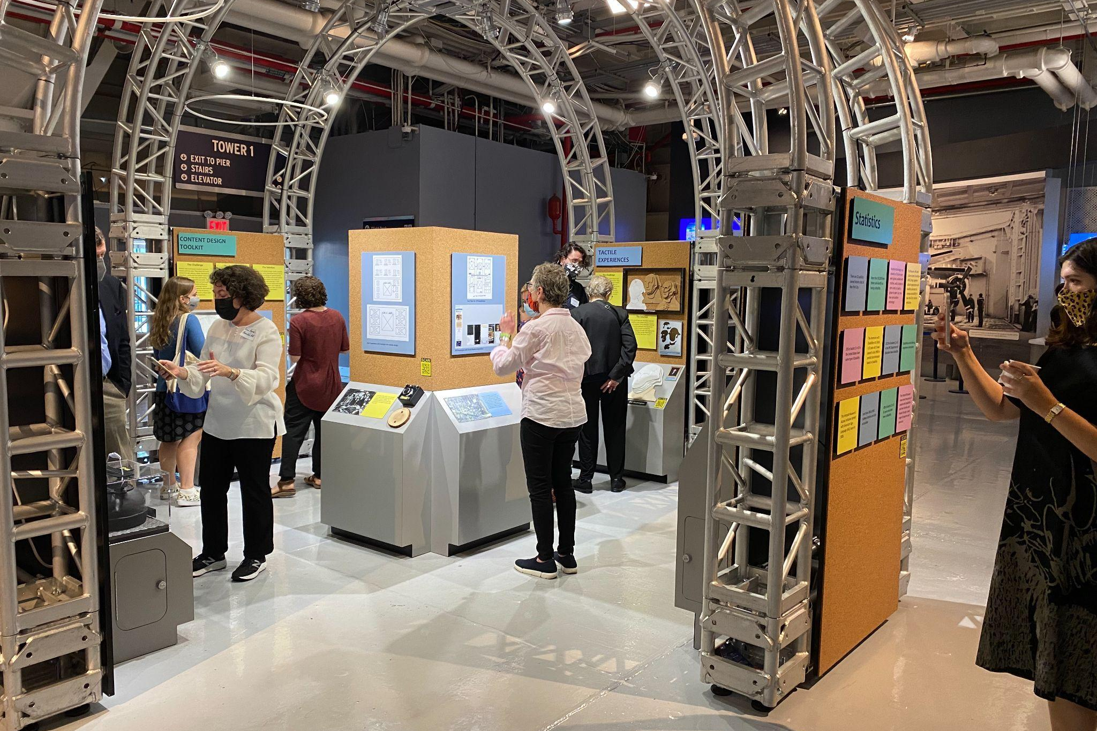
Caption: Making History Accessible, an exhibit we developed to evaluate multisensory interpretation prototypes to help define the toolkit.

Project Checklist

Vision
How does a sensory component enhance the story you want to tell?
Based on the idea and your site, is the interpretation better told through a physical exhibit, a digital experience or a tour guide experience?
Outline the idea you are exploring and seek input and feedback to understand what may help make the story more dynamic or accessible.
Is it creating an inclusive experience vs. a separate experience? The concept should have meaning for all visitors or fill a gap currently faced by a specific audience.

Staff and Support
Identify your access advisors from the very start of the project. Learn from them all along the way. Invite them to your site or organize a virtual meeting. You can even reach out through your organization’s social media channels.
Besides the external talent (access consultants and fabrication/fabrication vendors), who at your organization will be involved with the project? From a time and cost perspective, how does it impact operations, the communications web team, and the exhibits and/or education staff person?
Create an internal working group and assign one staff person to serve as the project lead.
Evaluate the experience internally to assess its implementation and maintenance. Can the experience be sustained? Is it too expensive and time-consuming?

Approach and Execution
Start small. If a project is too ambitious or expensive it may never be pursued.
When planning the project and seeking funding, identify a budget line to pay your access advisors.
When working with a vendor, discuss the full context of your project, the specific idea and the full cost and timeline. For physical/tactile projects, clarify if its material will need to be reproduced because of wear and tear. Is it more cost efficient to create multiples for future use? Make sure to put all the ideas and all the costs in writing and review with the vendor so that everyone fully understands the vision, costs and implications.
Try to be iterative when designing and testing your project so that you can learn from visitors.
Evaluate the user experience. Do visitors use what you have created? Do they learn from it? Which visitors do or do not engage with it? Consider the Evaluation templates in the Appendix to conduct observations. Make assessments and tweak the project.
If you are working with images and/or film footage, you must secure rights and permissions, and make sure it is accessible to people with vision or auditory impairments through closed captions, audio or visual description and alternative text.

Sample Letter/Email
Below is a sample email sent to a targeted audience to join an advisory council at the Intrepid Museum:

Dear __________,

The Intrepid Museum is looking for self-advocates to join its Autism Advisory Council for the year! The Autism Advisory Council will:
- Discuss new exhibits and initiatives
- Give feedback on Access Programs
- Talk about current concerns in their communities and share resources

A good fit for the Autism Advisory Council is someone who is interested in cultural institutions, and would like to join us in creating more accessible and inclusive spaces. Autism Advisory Council expectations are:
- Attend at least 3 of 4 meetings a year.
  - There will be two meetings in person at the Museum and two meetings on Zoom.
  - Meetings start at 6:00pm ET.
  - Meetings at the Museum are 2 hours.
  - Meetings on Zoom are 1.5 hours.
- Attend at least 1 Access program and provide detailed verbal or written feedback.
- Autism Advisory Council Members will receive a $75 honorarium per meeting attended.

Individuals that complete these expectations will also receive a Family Membership to the Museum for one year as a thank you for their participation.

For more information, please email _________ at _____________.

All the best,

Signature Line

Local Community Organizations + List
Below are some national disability organizations that also have local or regional chapters or affiliates. These can be a great starting point. Many communities also have local networks, schools, agencies and advocacy groups that historic sites and house museums should contact:
- National Federation of the Blind - https://nfb.org/
- National Association of the Deaf - https://www.nad.org/
- Hearing Loss Association of America - https://www.hearingloss.org/
- Autistic Self Advocacy Network - https://autisticadvocacy.org/
- Clubhouse International - https://clubhouse-intl.org/what-we-do/international-directory/ (mental illness)
- Learning Disabilities Association of America - https://ldaamerica.org/
- United Spinal Association - https://unitedspinal.org/
- United Cerebral Palsy - https://ucp.org/
- The Arc - https://thearc.org/ (intellectual disabilities)
- Disabled American Veterans - https://www.dav.org/
- Alzheimer’s Association - https://www.alz.org/
- ADA National Network - https://adata.org/national-network
- American Occupational Therapy Association - https://myaota.aota.org/asapcontacts.aspx
- Accredited local and regional Occupational Therapy universities and colleges - https://acoteonline.org/schools/

A number of regions and cities also have accessibility organizations that historic sites and house museums can contact, such as:
- Museum, Arts and Culture Access Consortium in NYC - https://macaccess.org/
- Cultural Access Collaborative in Illinois - https://culturalaccesscollaborative.org/
- Art-Reach in Philadelphia - https://www.art-reach.org/

Evaluation Templates

Example Surveys
Below are examples of two surveys. It is optimal to provide them on paper and digitally, as some visitors may have a preference.

Digital Project: Digital Mobile Guide: Accessing Information from Your Phone or Tablet
How likely are you to access information and content through your own phone or tablet? (Choose one):
☐ Extremely likely
☐ Very likely
☐ Not sure
☐ Somewhat likely
☐ Not likely at all
Rank the elements you would be most likely to use when accessing information from your own phone or tablet on a scale from 1 to 5. Where 1 is information you are extremely likely to use, 3 is information you are not sure if you would use, and 5 is information you are not likely to use.

 | 1: Extremely Likely to Use | 2 | 3: Unsure | 4 | 5: Not Likely to Use
Maps | ☐ | ☐ | ☐ | ☐ | ☐
Information about areas I can’t get to physically | ☐ | ☐ | ☐ | ☐ | ☐
Additional information that expands on the exhibits and places I can get to physically | ☐ | ☐ | ☐ | ☐ | ☐
Information about the logistics of traveling to an area, such as the distance to get there, if there are stairs or an elevator, if I need to climb a hill or other natural terrain | ☐ | ☐ | ☐ | ☐ | ☐
Sensory information about the areas I may visit such as sound levels, size, or the likelihood of crowds | ☐ | ☐ | ☐ | ☐ | ☐
Historical sounds of spaces that I am walking through | ☐ | ☐ | ☐ | ☐ | ☐
Information about the smells in the location or potential for allergens | ☐ | ☐ | ☐ | ☐ | ☐
Themed tours of the site or museum | ☐ | ☐ | ☐ | ☐ | ☐

Other:
Tactile Project: Bring Stories out from Behind the Glass: Stove from the Louisiana State Museum
Which told you the most about the stove? (Choose one)
☐ Reading about the stove
☐ Looking at the photos of the stove
☐ Touching the full-size replica of the stove on the wall
☐ Lifting the tea kettle
Other:

Which told you the most about human story connected to the stove (Choose one)
☐ Reading about the stove
☐ Looking at the photos of the stove
☐ Touching the full-size replica of the stove on the wall
☐ Lifting the tea kettle
Other:

Observation Protocol
We created an observation protocol for user testing of our prototypes.
The goal: To gain insight into how users might naturally interact with the prototypes.
The approach: Users will be asked to interact with the prototype, with staff giving very little prompting. Each user should interact with the prototypes for about 5 minutes. Encourage users to "think aloud" while they interact with the prototype(s) and make notes on their thoughts as well as your observations of their actions.
This can be done in small groups or with individuals.
Make note of the age range and other demographics of either the individual or the group.
What we are looking for:
- What are users interacting with the most?
- What are they avoiding?
- What are they confused by or find unclear?
- What would they like to see more of?
- What do they dislike?
- Are they doing anything unexpected?
These questions may be answered through observation or by the unprompted user answering during their think aloud.
Below is an example of the rubric we used.

User Testing Observations

User Testing Observations

Institution: _______________________________
Date:
Time of Observation:
Observer’s name:
User Group/Individual:
# of adults _________ # of children_________
Age Range:

- 0 – 3
- 4 – 6
- 7 – 12
- 13 – 17
- 18 – 25
- 26 – 35
- 36 – 45
- 46 – 55
- 55 – 62
- 62+

Observation #:

Notes about User: (needs, comments they might say before observation)

Goal of Observations: Gain insight into how users might naturally interact with the prototypes.
What we are looking for (These questions may be answered through observation or by the unprompted user answering during their think aloud):
- What are users interacting with the most?
- What are they avoiding?
- What are they confused by or find unclear?
- What would they like to see more of?
- What do they dislike?
- Are they doing anything unexpected?
Notes: Users will be asked to interact with the prototype, with staff giving very little prompting. Each user should interact with the prototypes for about 5 minutes. Users will be encouraged to think aloud.

Project Case Studies
Many historic sites and house museums must display objects and artifacts in a protected environment. They are too fragile for visitors to hold or touch, and reproductions can be expensive or easily worn down. However, tactile (touch) experiences can help all visitors better understand an object or storyline. This is especially important for visitors who are low-vision, blind, neurodiverse and tactile learners.

Below are some of the key prototypes created by the historic sites and house museums participating in the project. Case Studies 1-3 include tactile experiences. Case Study 4 uses smell to enhance storytelling. Case Study 5 features digital experiences. Case Studies 6-7 focuses on methods to make the stories as accessible as possible.

Case Study 1: Tactile Experience
Macculloch Hall Historical Museum has the largest collection of work by artist Thomas Nast (1840-1902). Known as the "father of American political cartooning," he also popularized the image of Santa Claus. The Museum wanted to make Nast's iconic image of Santa, "Merry Old Santa Claus" published in "Harper's Weekly" on January 1, 1881, accessible to all visitors.

Using a high-resolution photograph, they commissioned a touch portrait translating Nast's engraving on newsprint into a large (2 ft. x 3 ft.), contoured portrait with raised lines. It invites visitors to experience the engraving with their fingertips. Visitors can feel through touch the pictorial elements of Nast's most famous image of Santa Claus. It's heavy and has a coated surface that can be cleaned with a damp cloth and mild disinfectant.
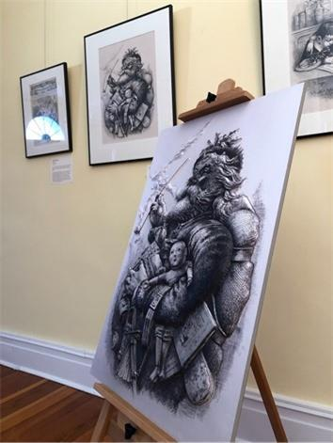 | Caption: A large, sturdy reproduction with raised surfaces invites visitors to touch and feel the image of the iconic Santa Claus.

Case Study 2: Tactile Experience
Historic sites and house museums are artifacts themselves. The buildings and the objects provide clues to the past. However, to preserve these spaces, sites sometimes need to keep areas and artifacts behind glass, or make them unavailable to the public. These barriers especially impact visitors with disabilities who may rely on different senses to interpret information.

The Louisiana State Museum’s 1850 House in New Orleans provided a test case for prototyping, designing and testing ways to bring sensory opportunities out from behind glass. Bringing key reproduced elements of the stove to visitors for sensory exploration included:
- Illustrating the scale of the stove through a mix of flat graphics and 3D reliefs.
- Conveying the heavy weight of the object without ever touching the actual one.
  - Visitors lift a reproduction of a cast iron pot in a controlled, safe and secure manner.
- Providing a way to smell the distinctive odor of the cast iron, the same material of the original stove.
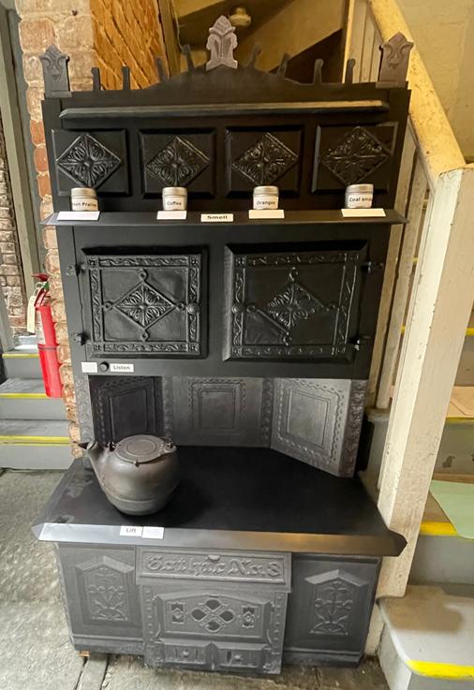
Caption: Left, a full-scale reproduction of a 19th century stove that recreates the intricate molding of the original cast iron, and includes a cast iron kettle and scent jars. Right, a close-up of a visitor using both hands to feel the intricate patterns on the reproduction of the 19th century stove.

Case Study 3: Tactile Experience
Eastern State Penitentiary in Philadelphia, Pennsylvania represents one of the most influential prison designs of the early 19th century. The most important artifact is the building itself. This can be a difficult component to grasp. Rather than a smaller scale 3D model under glass, the team created a scale model that can be carried during tours so that visitors can see and touch, and get a sense of the context of the innovative design. Due to the size of the building, the team developed several prototypes to determine the appropriate scale and level of detail for different uses.
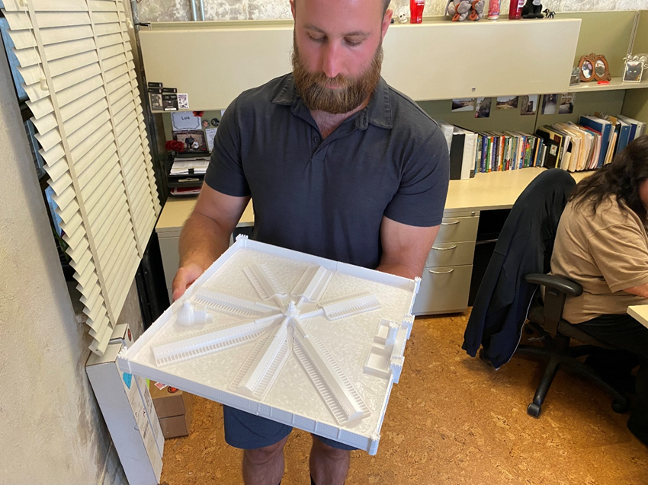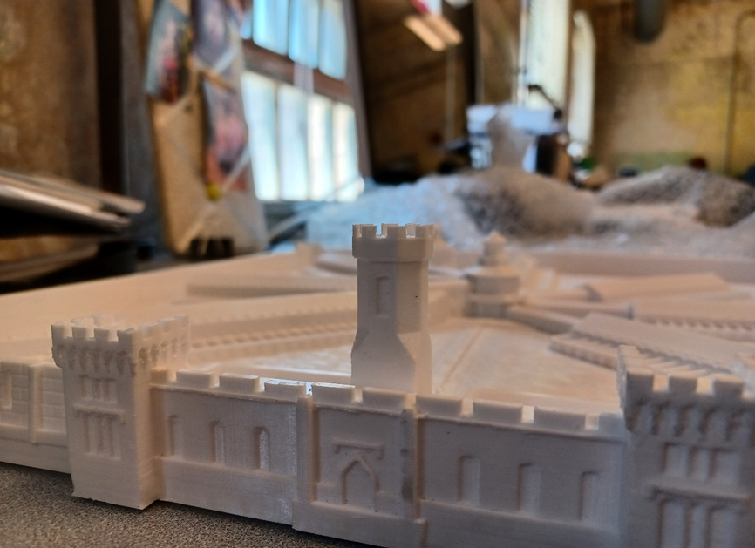
Caption: Left, a staff person holds a 3D-printed scale model of the full exterior of Eastern State Penitentiary. Right, a close up image of the model showing the arched windows and details on the outer walls and turrets.

Case Study 4: Olfactory Experience
Museum exhibits traditionally focus on the senses of sight and sound. Bainbridge Island Historical Museum in Washington State developed sensory-based storytelling to enhance some key elements of their story. The team experimented with ways to keep the smells contained to avoid overwhelming visitors.
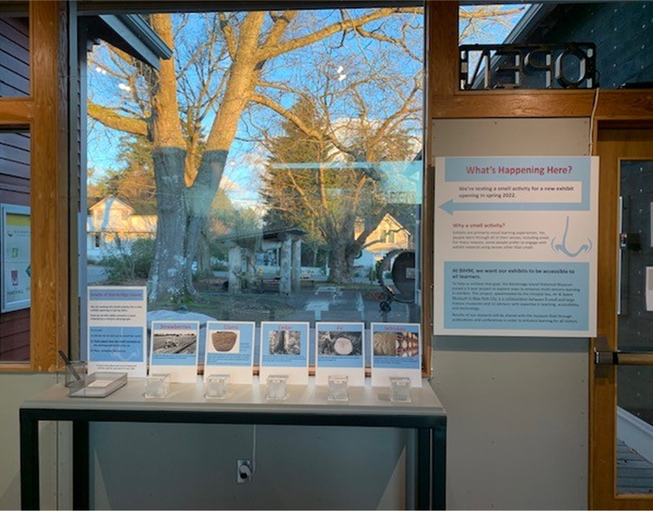 | Caption: Bainbridge Island Historical Museum tested five smells by placing the smell boxes (strawberry, cedar, fir, whiskey and clam) on a table in the exhibition with related images and a simple survey for visitors.

Case Study 5: Digital Mobile Guide
Preserving historic spaces can often present a direct challenge to creating a welcoming and inclusive learning experience. Narrow hallways may block many visitors, including those who use wheelchairs, from exploring and seeing labels in those areas. Unconventional floor plans or vast outdoor spaces can be confusing to navigate without a guide, especially for visitors who have difficulty following visual maps, or who have low-vision or are blind. Physical maps, audio guides and tactile cards can be complicated and expensive to update.

Accessibly designed mobile websites allow users to access information on their own devices with their preferred settings. For example, a low vision or blind visitor can use digital text and image descriptions read aloud with a screen reader. Once basic templates are developed, these websites are easy to update. It enables an autonomous user experience.
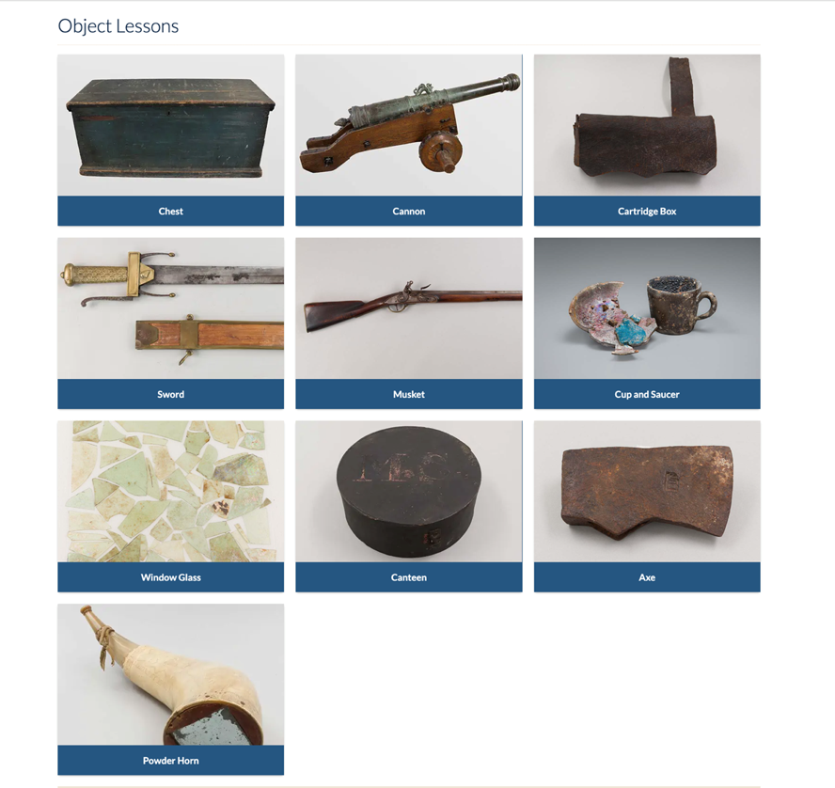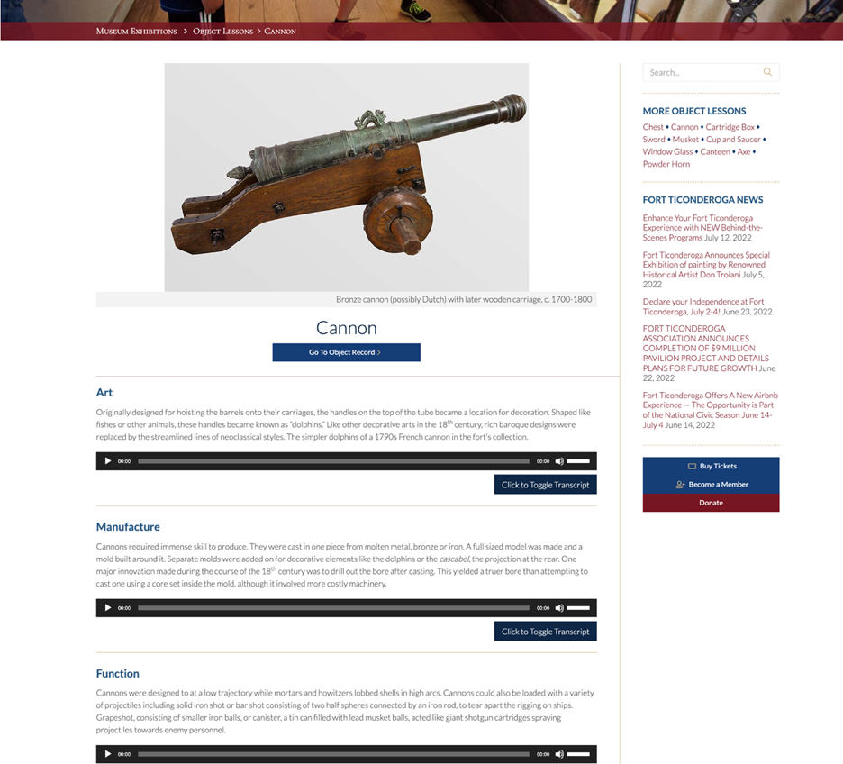
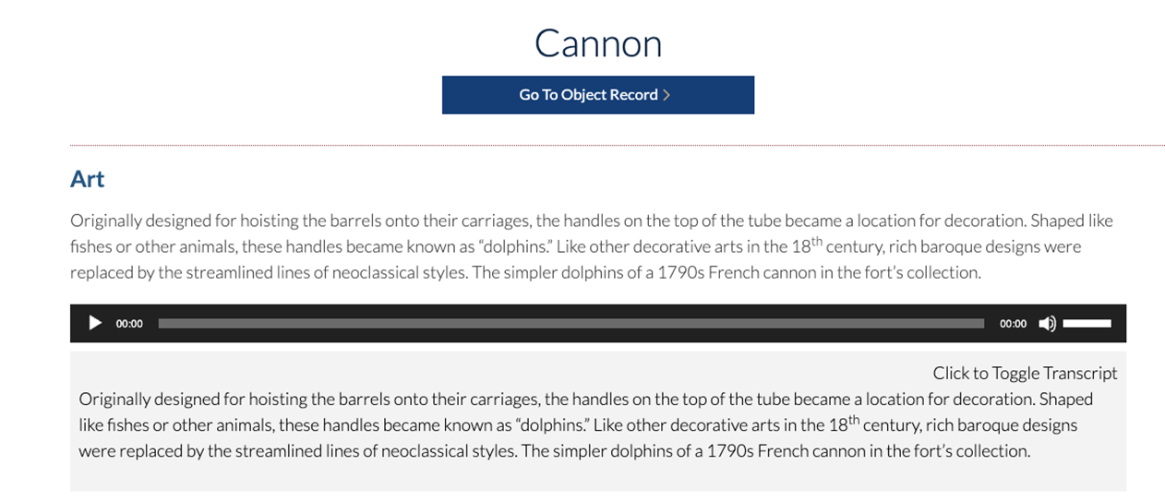
Caption: Screenshots of a digital mobile guide showing different levels of interpretation. Top left, ten images from the digital collection. Top right, one image featuring a cannon, along with layers of deep description. Bottom, illustrates the audio and transcript from the audio.

Case Study 6: Content
Historic sites and house museums connect visitors with the past. They share facts and stories through objects, labels, illustrations, educators, media, and the historic space itself. It is essential to make clear and inviting communication universally accessible. Exhibit labels that use technical jargon or overly complicated writing can frustrate visitors and discourage further reading. It can also be challenging for international visitors to read English. Photos, illustrations, and videos may prevent a visitor with limited vision from getting important information.

Toolkits can help museum professionals learn about best practices and where to find support to make their content and stories more accessible. Take advantage of the free and excellent resource, Smithsonian Guidelines for Accessible Exhibition Design.

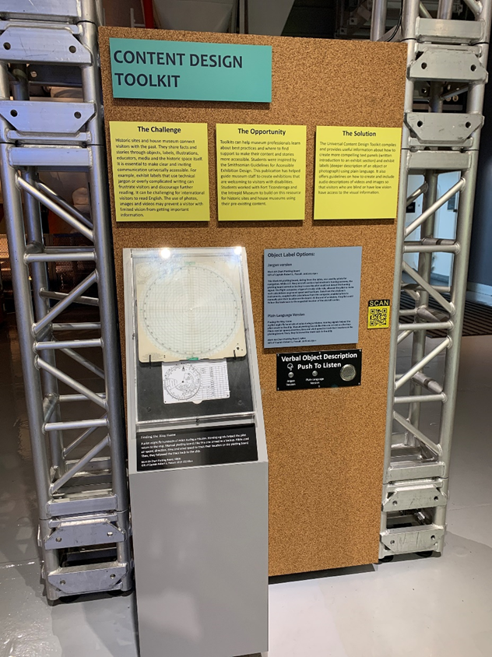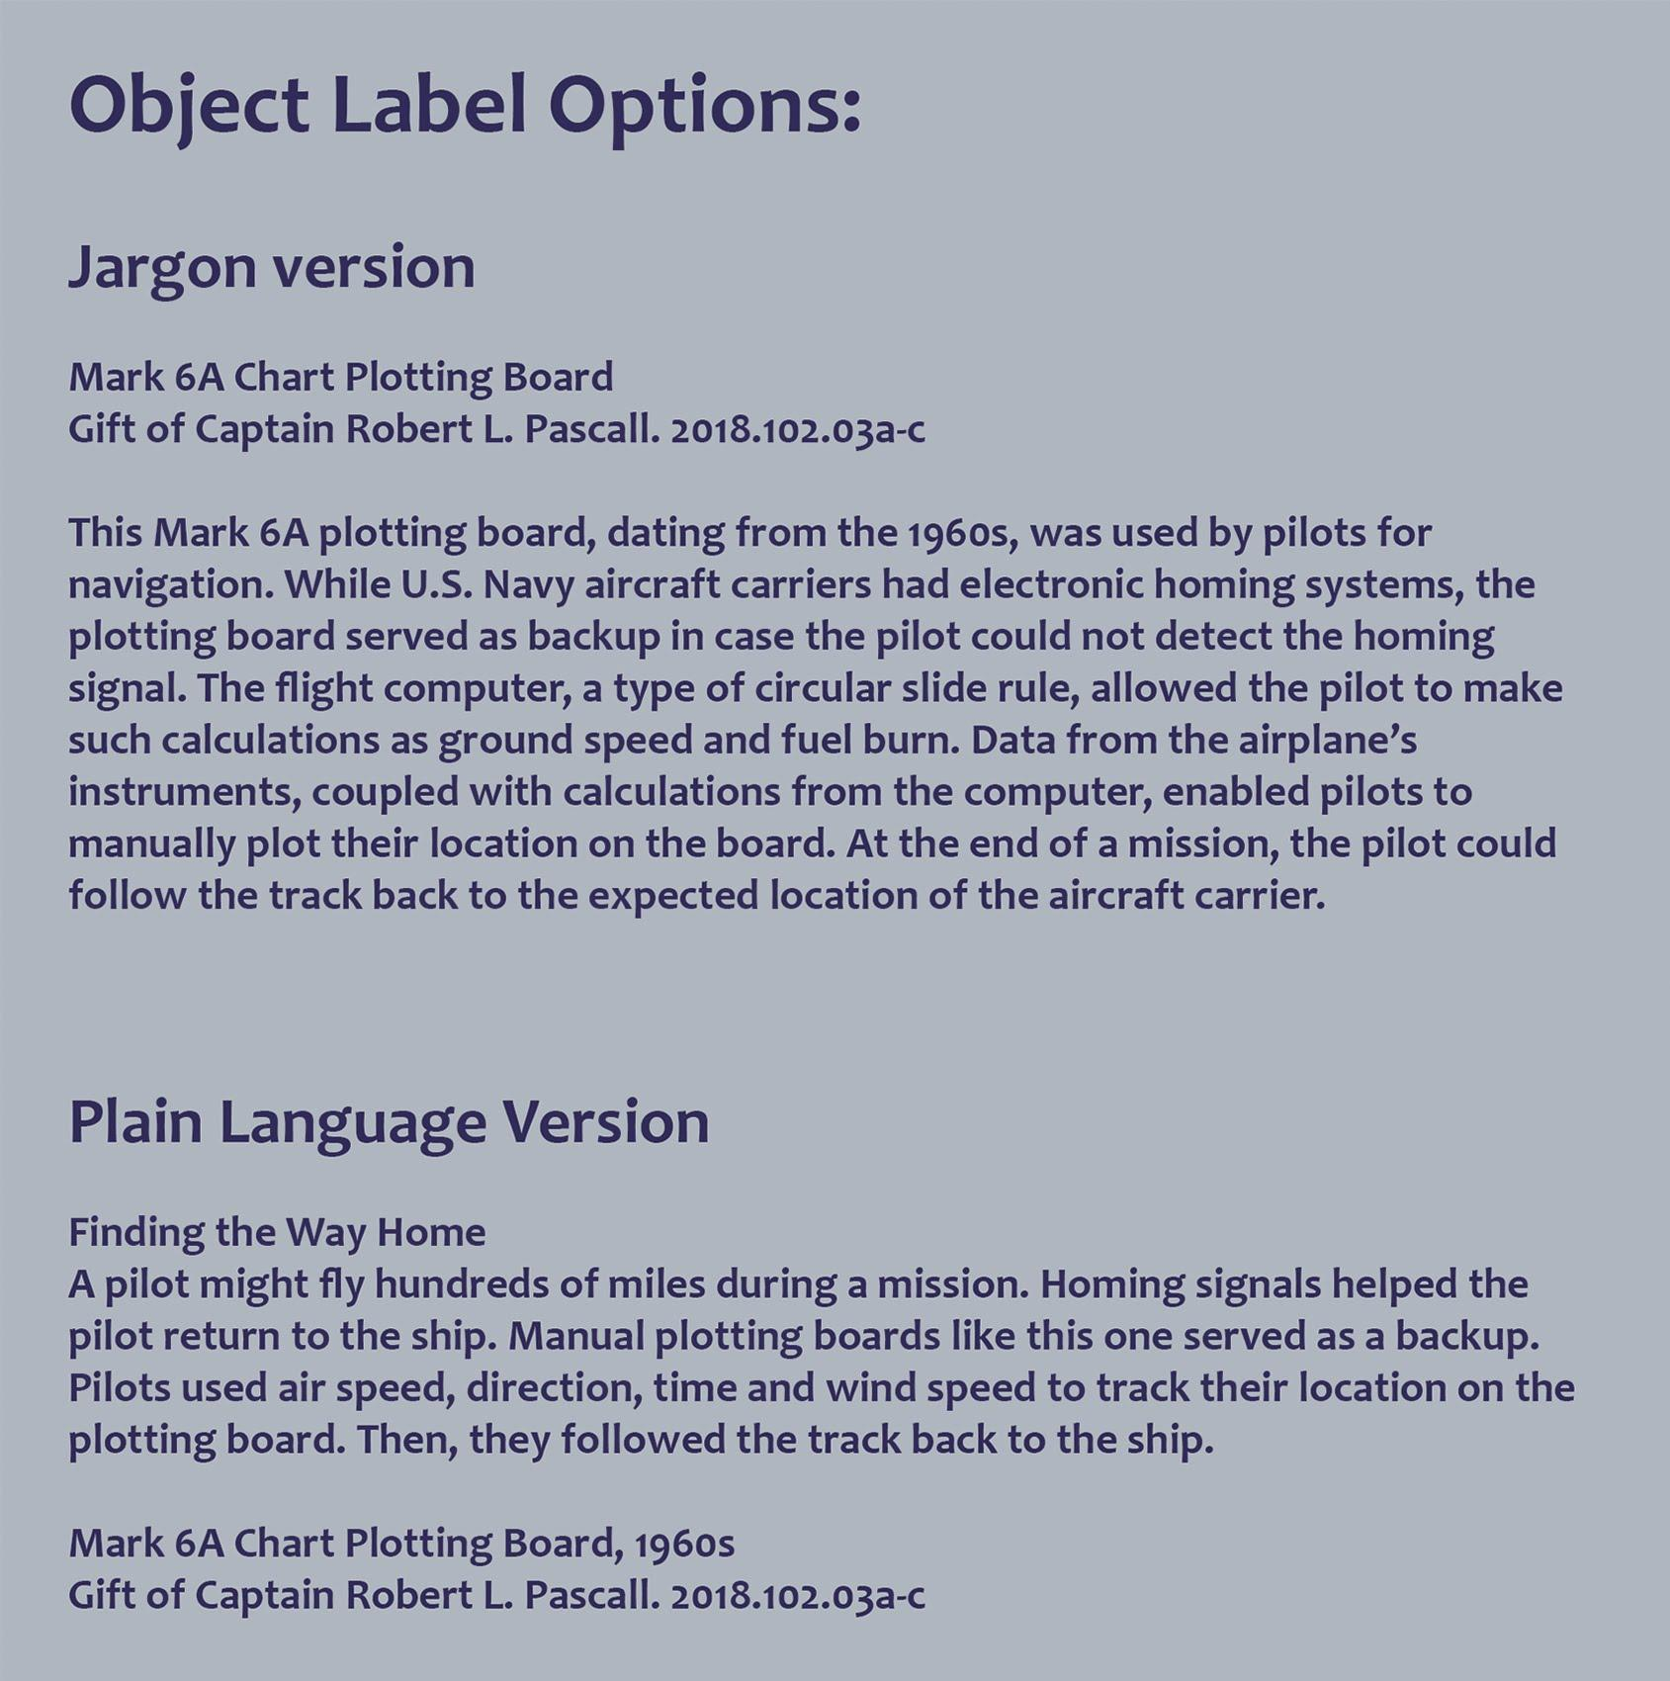
Caption: Left, this display of the Content Design Toolkit featured a navigational chart with two different labels and audio descriptions with different levels of technical detail and language. Right, the label copy for the navigational chart illustrates the difference between “jargony” technical and plain language.

Case Study 7: Multiple Perspectives
Multiple perspectives can provide an accessible entry point for all visitors, but especially visitors who are neurodivergent. First-person perspectives can also amplify voices that may have not been traditionally included.

Acknowledging the limited staff at historic sites and house museums, the team created accessible website templates that staff could easily update with new content. It can help to identify and collect missing stories without feeling overwhelmed by the technology needs to make this happen.
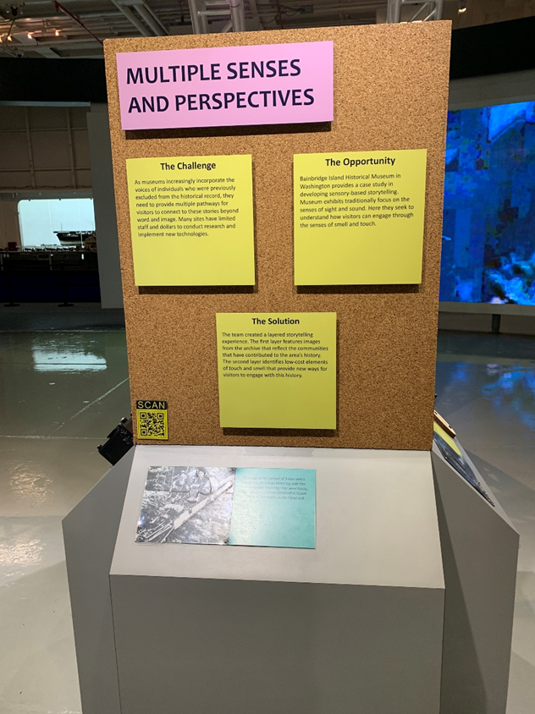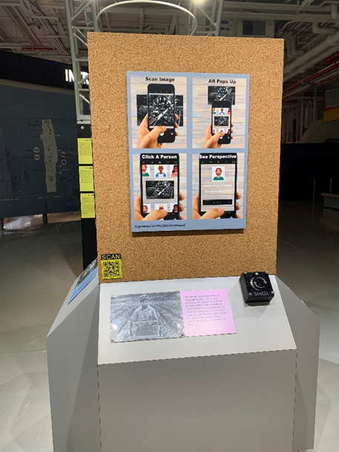
Caption: These two displays from Making History Accessible show two approaches to incorporating multiple perspectives. The bottom of both displays include a historic photo (with a tactile layer) paired with a different first-person perspective. The one on the right also included a smell box with strawberry scent to pair with the photo of a strawberry harvest. The right display also includes photos of templates for a digital guide featuring multiple perspectives.

